What is inflation, inflation is when there is an increase in the level of prices of the goods and services. Today we are going to explain how Dwelling CPI and the rate of fuel prices affect inflation in Australia.

There are three main causes for inflation, Demands pulled – when the total demand for good and services increase the supple of goods and services, the cost pull when the cost of production goes up in which the businesses need to pass on the cost.

The Exchange rate should have a huge impact on the inflation rate, due to the exchange rate effecting the prices of services and imported goods such as Oils and raw Materials which can then increase or decrease cost of production, however looking at theattached line chart.

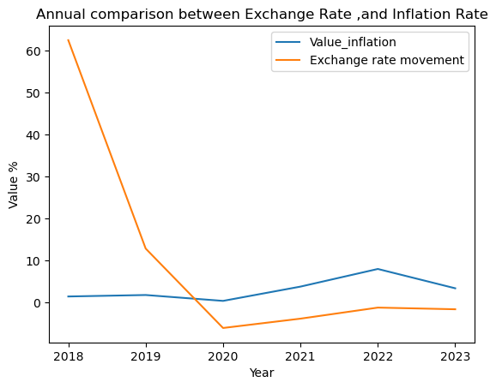between the inflation rate and the exchange rate, you can see that while 2018-2020 the exchange rate was on a decreasing trend, inflation rate didn’t move that much.

It wasn’t until 2020 when the exchange rate started to get better that the inflation rate started to rise, this could be because the pricing of goods and services had to increase to cover the loss of both during the covid pandemic which had an impact on inflation and the exchange rate due to Australia being dependant on other countries for imported goods such as fuel from Singapore which had lockdown rules implied and workers were not working and other countries were not letting ships port.

**CPI**

The best way to tell if inflation is occurring is through the Consumer Price Index (CPI) reports which is a collection of products and services and how much they have moved since the pervious quarter.

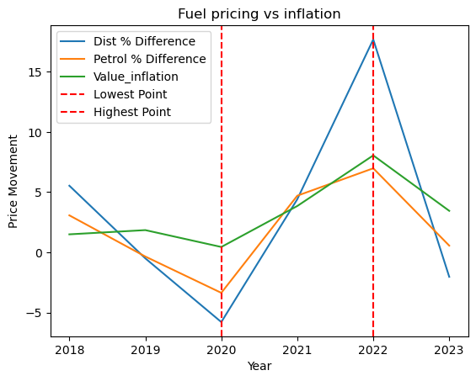

As you can see by this line graph comparing inflation and retail prices over the last five years you can see all were the lowest point during 2020 due to Covid-19 this was due to having less people on the road, less people spending money on goods and services and less people traveling due to lock down.

Following the lockdown changes and the rate that consumers were then using fuel, the pricing started to grow until 2022 when the Ukraine War started and it has been on the decline since.

Comparing this to the Inflation line you can also see that the inflation rate started to decrease as well, proving the fact that Diesel/retail pricing can have a huge impact on inflation due to it powering trucks, cars, trains, machinery, agriculture equipment which all causes the rise of production and business then need to raise the price on goods and services which can cause the Australian reserve to raise interest rates.